**Exercise:**

**Plotting Education Data**

The following line graph shows the percentage of women who have received a bachelor's degree over the years in the USA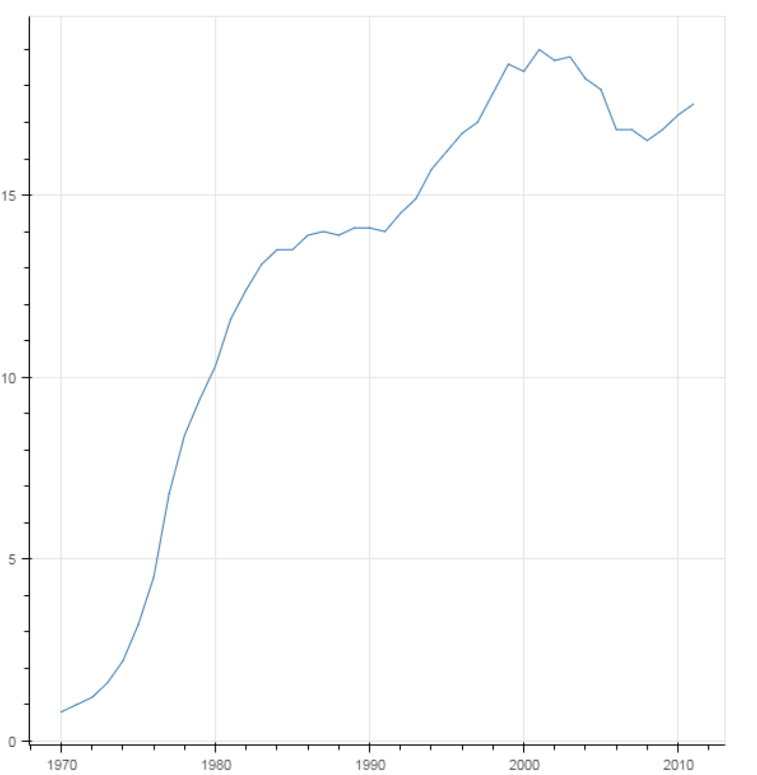. The graph was produced from the Year  and Engineering columns of the CSV file provided in the following link:

<https://pythonizing.github.io/data/bachelors.csv>

*Try to reproduce the graph using Bokeh.*